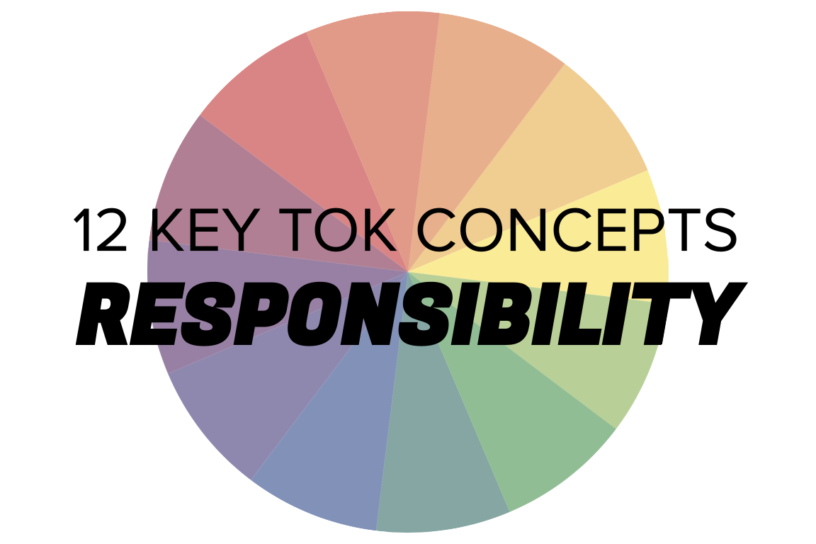 | RESPONSIBILITY

Understanding the 12 key concepts
- The 12 key concepts are ones that have been identified as having a particular significant relationship to knowledge.
- Understanding, exploring, and using these concepts will help you to understand the way knowledge is produced and used, within the core and optional themes, and the areas of knowledge.
- You should also try to use the key concepts as extensively as possible in the two TOK assessment tasks.
Starting points for responsibility  - How many online definitions can you find for ‘responsibility’?  - Which one do you think best sums up this concept, and why?  - Which of the quotes below do you think provides us with the best insight into responsibility? Are there any you disagree with?  - Do we have responsibilities when it comes to finding out about the world, and using knowledge? | Quotes on responsibility  - We are made wise not by the recollection of our past, but by the responsibility for our future. George Bernard Shaw  - We are at the very beginning of time for the human race. It is not unreasonable that we grapple with problems. But there are tens of thousands of years in the future. Our responsibility is to do what we can, learn what we can, improve the solutions, and pass them on. Richard P. Feynman  - There's a power in what we hold as artists, and part of that comes with responsibility... to share the human experience and really allow that to be seen. Tracee Ellis Ross  - True education flowers at the point when delight falls in love with responsibility. Philip Pullman  - People are often quite lazy. We like taking the easy way out - we like handing over responsibility, we like being offered shortcuts that mean we don't have to think. Hannah Fry  - In general I think that in art you only have the responsibility to tell the truth. Ken Loach
Interlinking the key concepts  - Is it our responsibility only to make claims about which we are certain?  - Do we all have a responsibility to search for the truth about the world?  - Who has responsibility for the way knowledge is interpreted?  - Is it our responsibility to justify all the claims we make?  - Do we have a responsibility to approach knowledge objectively? | Relating responsibility to the TOK course  - Do certain areas of knowledge carry with them more responsibilities than others?  - How should we use language responsibly to communicate ideas?  - Do members of indigenous societies have a clearer idea of their responsibilities as knowers?  - Do we have a responsibility to overcome our political and religious affiliations when we produce knowledge?
Relating responsibility to the TOK exhibition  - IAP-15: Think about our responsibilities to adhere to constraints on the pursuit of knowledge  - IAP-16: Think about our responsibilities to identify ethically questionable methods of producing knowledge  - IAP-22: Think about extra responsibilities that come with being expert knowers  - IAP-27: Think about our responsibilities to be aware of any ethical obligations that come with the possession of knowledge | Relating responsibility to the Big Questions  - BQ1 - What are our responsibilities as members of an epistemic community?  - BQ2 - What moral responsibilities do we have as knowers?  - BQ3 - Do we have a responsibility to communicate knowledge in a non-partisan way?  - BQ4 - Is it our responsibility to try to overcome perspectives as knowers?  - BQ5 - How do the responsibilities of knowers change over time?  - BQ6 - How do experts approach their responsibilities as knowers?

Real-world contexts for responsibility
The media sources below explicitly mention responsibility (or responsible), and discuss this key concept in a real-world context. Use the find command (ie Command/Control+F) to locate the term in the article or transcript of the video, and you’ll see where it features. Check back regularly, as we update these media sources every month.
Big Question / knowledge framework | Description of media source and story and links to the course
BQ1 / Nature & scope | A Conversation article, exploring how ‘magical thinking’ was once at the heart of science and religion, and why it could help the world today. Natural sciences, religion, knowledge & the knower
BQ2 / Values | An FT article, looking at (depending on your political perspective) the ‘banning’ or the ‘curating’ of school books in certain US states. The arts, Politics, Language, Human sciences  A Project Syndicate article by Peter Singer, analysing Elon Musk’s claims to be a ‘free speech absolutist’. Technology, Human sciences, Politics  A Guardian article and photo gallery, showing what pregnancy tissue from 5 to 9 weeks actually looks like. Natural sciences, Politics, Religion  A Guardian article, considering the life and work of the wonderful Jane Goodall, who has just won the Templeton Prize. Natural sciences, human sciences  A Guardian article about how various celebrities are now promoting theories about Covid-19 on social media that are unsupported by valid evidence. Natural sciences, technology, knowledge & the knower
BQ3 / Methods & tools | A Wired article that explores the relationship between technology transparency and the communication of valid accurate knowledge. Politics, technology
BQ6 / Methods & tools | A BBC article, discussing how to debate with those who reject conventional scientific thinking. Knowledge & the knower, Natural sciences  A Big Think article, exploring the line between ‘healthy skepticism’ and ‘toxic denialism’. Knowledge & the knower, most AOKs & themes  A Guardian article, considering the way celebrities are offering advice about dealing with Covid, and how this is undermining the work of legitimate medical experts. Natural sciences, language

